Design: Market Data Report Service

Overview

Current processing
New Functionality

New requirement
To cater to the different reporting requirements a new Service called MarketDataReportService will be created. This service will be running in a new process called MarketDataReportServer on the MDGC box.
HVOL, VOL, DSP and End of Day & Half Hourly Reports to NewsWire and Half Hourly Reports to OPRA, Update Close EEOD will be dependent on this new process once rolled out fully.

Scope of Document:
The scope of the document is to
- In goMaster load all recap information from database ,If data is not populated in recap cache,then populates the RecapCache , taking the required information from TSS , PMS and Derived Cache.
- Update recap cache for products by listening to last Sale event channels
- Dispatch the Last sale data to one of the n processing queues. On the other side of the queue it will find the MarketData associated with the product. Update the recap information in recap object. Create the history entry for each of the last sales received.
- Persist the ticker details in the recap_for_reports and market_data_hist_for_reports.
- Create MarketDataReportServiceRoutingProxy & related configuration
- Populate struct for HVOL
- Populate struct for VOL
- Consume Open Interest data.

Market Data Report Process Flow
- Initialize the Recap Cache, Build Recap Cache from Database
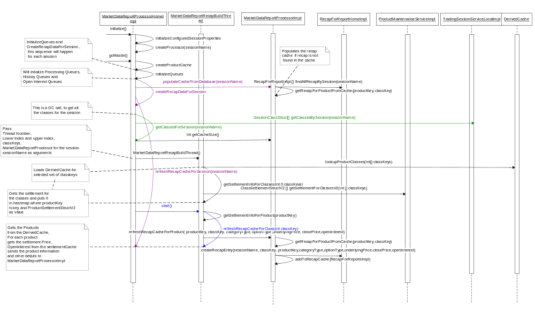

- Listen to Ticker Channel and enqueue in Processing Queue

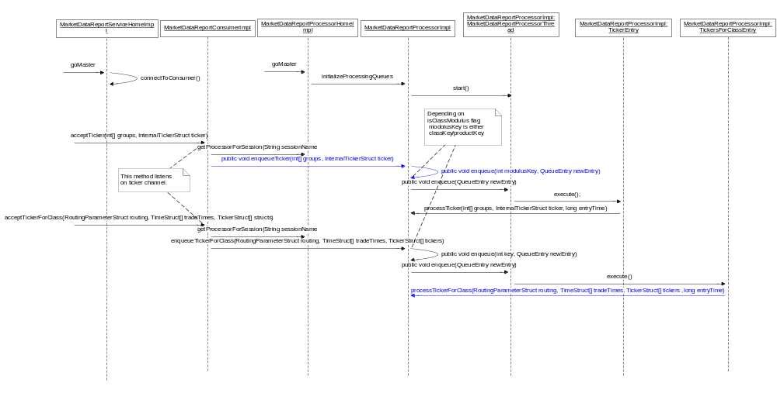

- Create or update Recah Cache, Enqueue to history queues after dequeuing from processing queue

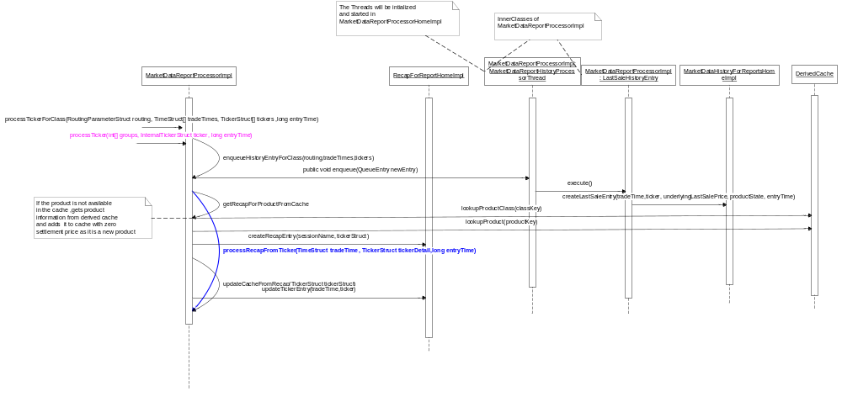
d. Listen to OpenInterest event, Enqueue to Open Interest queues, Updates Recap cache after dequeuing.

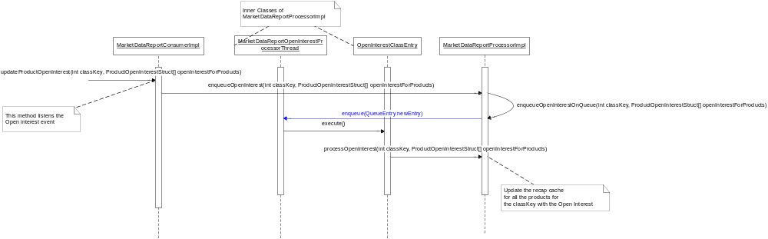

Implementation

Define idl for Market Data Report Service.
- Create a new idl file called as MarketDataReportService.idl in server/idl directory.
Define an interface MarketDataReportService in the idl
Define the following methods and interfaces in the idl

  - VOL
cmiProduct::ProductClassVolumeStruct getProductClassVolume(in string sessionName, in cmiProduct::ClassKey classKey)
raises(
exceptions::SystemException,
exceptions::NotFoundException,
exceptions::DataValidationException,
exceptions::CommunicationException,
exceptions::AuthorizationException
);
  - HVOL & Half Hourly Reports to NewsWire and OPRA
    - interface GainersLosersTypes
{
const businessService ::GainerLoserType GAINER = 'G';
const businessService ::GainerLoserType LOSER = 'L';
const businessService ::GainerLoserType UNCHANGED = 'U';
};

    - typedef char GainerLoserType;

struct VolumeStruct
{
long callsVolume;
long putsVolume;
long totalVolume;
};

    - struct GainersLosersStruct
{
businessService::GainerLoserType gainerLoser;
long gainerLoserCount;
};
    - typedef sequence < GainersLosersStruct> GainersLosersStructSequence;

struct GainersLosersByOptionTypeStruct
{
cmiProduct::OptionType anOptionType;
GainersLosersStructSequence gainersLosers;
long totalGainersLosersUnchanged;
};
typedef sequence <GainersLosersByOptionTypeStruct>GainersLosersByOptionTypeStructSequence;

    - struct MostActiveSeriesStruct
{
cmiProduct::ProductNameStruct seriesInfo;
long tradedVolume;
cmiUtil::PriceStruct lastSalePrice;
cmiUtil::PriceStruct netChange;
long classVolume; // This is added for HVOL
};
typedef sequence < MostActiveSeriesStruct> MostActiveSeriesStructSequence;

    - struct HalfHourlyReportByCategoryStruct
{
cmiProduct::ProductType category;
VolumeStruct aVolumeStruct;
long totalOpenInterest; // This is added for HVOL
GainersLosersByOptionTypeStructSequence gainersLosersSequence;
MostActiveSeriesStructSequence topTenMostActiveCalls ; // This is added for HVOL
MostActiveSeriesStructSequence topTenMostActivePuts ; // This is added for HVOL
};
typedef sequence < HalfHourlyReportByCategoryStruct> HalfHourlyReportByCategoryStructSequence ;

    - struct OptionsHalfHourlyReportStruct
{
cmiUtil::DateTimeStruct generationTime;
VolumeStruct totalVolumeStruct;
GainersLosersByOptionTypeStructSequence totalGainersLosersSequence;
HalfHourlyReportByCategoryStructSequence aHalfHourlyReportByCategoryStructSequence;
MostActiveSeriesStructSequence overallTopTenMostActiveSeries;
};

  - UPDTCLOSE and Electronic EOD
    - marketData::ClassRecapStructV5Sequence getClosingRecapForClassesV5(
in cmiSession::TradingSessionName sessionName,
in product::ClassSettlementStructSequence classSettlementStructs)
raises(
exceptions::SystemException,
exceptions::CommunicationException,
exceptions::DataValidationException,
exceptions::AuthorizationException
);
  - Display Series Price
    - cmiMarketData:: ClassRecapStructV5 getRecapForProduct (in cmiSession::TradingSessionName sessionName, in cmiProduct::ProductKey productKey)
raises(
exceptions::SystemException,
exceptions::CommunicationException,
exceptions::DataValidationException,
exceptions::AuthorizationException,
exceptions::NotFoundException
);

Define interfaces for Market Data Report Service.
- Define the following Interfaces in
Location: server/Java/interfaces/com/cboe/interfaces/businessServices
  - MarketDataReportService.java
This interface will extend com.cboe.ffidl.ffBusinessServices.MarketDataReportServiceOperations
  - MarketDataReportServiceHome.java
This class will declare the find () and create () methods.
  - MarketDataReportServiceLocalHome.java
  - MarketDataReportServiceLocal.java
  - MarketDataReportProcessorHome.java
  - MarketDataReportProcessor.java
- Define the following interfaces in
Location: Server\Java\impls\com\cboe\businessServices\marketDataReportService
- MarketDataReportConsumer.java
Extend the interface with TickerConsumer and ProductStatusConsumer interface.
- MarketDataReportServicePropertyHome.java
This interface provides method to get the session list, Configured groups,InstanceNumber and instance Id .

- Define the following interfaces in
Location: domain/Java/interfaces/com/cboe/domain/marketDataReportService
- Required for Persistence of Last sale data in history and recap table.
- MarketDataHistoryForReports.java
- MarketDataHistoryForReportsHome.java
- RecapForReportHome.java
- RecapForReport.java

Define the implementation classes.
- MarketDataReportServiceImpl.java
Location: server/Java/impls/com/cboe/businessServices/marketDataReportService
This class will be having the methods required by HVOL, VOL etc.

- MarketDataReportServiceHomeImpl.java
Location: server/Java/impls/com/cboe/businessServices/marketDataReportService

- Extends ServiceHome
- Implements MarketDataReportServiceLocalHome as the service will also be used locally & by the external services.
- Inside Constructor of the MarketDataReportServiceHomeImpl , set the smaType to ‘GlobalMarketDataReportServiceHome.MarketDataReportServiceHomeImpl’
- Define method goSlave()
    - Load the following services.
      - Create tie object for service and connect to POA. Tie Object for market data report service will be created using the POA_MarketDataReportService_tie class.
- Define method goMaster()
    - Load the following services
      - Connects to ticker channel and product status channel
      - Call connectToConsumers()
    - Export the service with following properties read from MarketDataReportServiceProperty.xml by calling method exportOffer() These properties are required to run the server in Master/Master Mode
      - Route Name
      - Session Name
      - Process Name
      - Instance Id
      - Configured group
- Define method protected void exportOffer(String helperId).
    - This method will export service with o Route Name, session name ,instance id, configured groups and processName.
    - Use POAHelper.exportWithMultipleValues method for exporting MarketDataReportService using service properties. Input parameters for this method will be as follows
      - POA Servant for service
      - service name - Generic service name will be obtained from com.cboe.domain.util.GenericName.getGenericName()method using helper id of MarketDataReportService
      - service properties – This is a java.util.Properties object which holds all parameter used for exporting the service as individual ArrayList. This will include ArrayList for Values of Session Name , Process Name, Instance Id & Configured Group in it .
      - Instance of MarketDataReportServiceHomeImpl
- Define the creator and finder method for the service.
- Define method public MarketDataReportServiceLocal findLocal(). This method will return the local home object of the MarketDataReportService.

- MarketDataReportServicePropertyHomeImpl.java
Location: server/Java/impls/com/cboe/businessServices/marketDataReportService
This class reads session list, Configured groups, InstanceNumber and instance Id for MarketDataReportService from MDRSPropertyHome.xml. It also Implements accesor methods for these properties.

- Last Sale and Open Interest Consumer Implementation
This consumer will listen to Ticker channel for acceptTicker/acceptTickerForClass and updateProductOpenInterest events. Based on the session will pass the data to corresponding MarketDataReportProcessorImpl Service.

- MarketDataReportConsumerImpl.java
Location: server\Java\impls\com\cboe\businessServices\marketDataReportService
- Implements MarketDataReportConsumer.java, Contains the map of all the MarketDataProcessorImpl based on configured session name obtained from MarketDataReportProcessorHomeImpl. Listens to acceptTicker, acceptTickerForClass for Ticker and updateProductOpenInterest events for open Interest data
- Define method public synchronized void acceptTickerForClass(RoutingParameterStruct routing, TimeStruct[] tradeTimes, TickerStruct[] structs)
    - Consume ticker event from Ticker channel.for acceptTickerForClass(RoutingParameterStruct routing, TimeStruct[] tradeTimes, TickerStruct[] tickers) method
    - Get the sessionName from routing and passes the data to appropriate marketDataReportProcessor
    - Calls enqueueTickerForClass(routing, tradeTimes, structs) on the marketDataReportProcessor.
- Define method public synchronized void acceptTicker(int[] groups, InternalTickerStruct ticker)
    - Consume ticker event from Ticker channel.for acceptTicker(int[] groups, InternalTickerStruct) method .
    - Get the sessionName from routing and passes the data to appropriate marketDataReportProcessor
    - Calls enqueueTicker(groups, ticker) on the marketDataReportProcessor
- Define method private MarketDataReportProcessor getProcessorForSession(String sessionName)
    - Returns the MarketDataReportProcessor object for the given session name from reportProcessorMap.
- Define method public synchronized void updateProductOpenInterest(int classKey, ProductOpenInterestStruct[] openInterestForProducts)
    - Listens on the updateProductOpenInterest event.
    - Gets the session code from the Derived cache obtained from MarketDataReportProcessorHome based on the classKey.
    - Gets the marketDataReportProcessor object from the cache by passing the obtained sessionName and enqueues the data to openInterestQueue using enqueueOpenInterest(int classKey, ProductOpenInterestStruct[] openInterestForProducts)

- Define method public string getNumberOfTickerAndOpenInterestRecieved()
This methods returns total number of tickers and product status events received on this
Consumer. This method is invoked from ar command – this command is registered from
MarketDataReportServiceHomeImpl. Modify MarketDataReportService.dtd for
Addition of AR command.

- MarketDataReportServiceHomeImpl.java
- Register MarketDataReportService as Listener for TickerEvents with TickerConsumerHome
- Register the MarketDataReportService as Listner to OpenInterest events with ProductStatusConsumerHome
- Create ChannelKey using ChannelType.ALL_TRADING_SESSION in MarketDataReportServiceHomeImpl
- Define below property in MarketDataReportService.xml to get the consumer’s implementation class.
<marketDataReportConsumerImpl>com.cboe.server.events. MarketDataReportConsumerHomeImpl</marketDataReportConsumerImpl>

- TickerConsumerImpl.java
Add a filter in TickerConsumerImpl for MarketDataReportService to listen to only those sessions which are configured in MarketDataReportService.xml
- Modify ChannelType.ALL_TRADING_SESSION section to add the inclusion filter.
- Add filter on acceptTicker and acceptTickerForClass method for all the sessions configured in MarketDataReportService.xml

- Market Data Report Service Processing Implementation

- MarketDataReportProcessorHomeImpl.java
Location: server/Java/impls/com/cboe/businessServices/marketDataReportService/
The class performs the following tasks
- Gets all the sessions and its properties from the MarketDataReportProcessor.xml in initialize method. If any of the property not found throws FatalFoundationExcption with appropriate message.
- Creates the RecapProcessors object for each configured session.
- Creates derived cache for MarketDataReportProcessor service.
- Initializes processing queus,open interest queues and history queues for each session .and creates a recap cache for each configured session.
- Builds number of threads which will create the RecapCache.
- Initializes the recap cache on MarketDataReportProcessorImpl from Database.
    - Loads the recap cache from database based on session.
    - Updates the cache details with categoryType and optionType from Derived cache as they are not persisted in database.
- Gets all the classKeys from TradingSessionService for the given session.
- If recap cache is empty , then invoke MarketDataReportRecapBuildThread to populate the recap cache .
Passes the classKeys to the MarketDataReportRecapBuildThread. Each thread will update the cache for only specific number of classes based on the upperIndex and lowerIndex for the classKeys array.

- MarketDataReportRecapBuildThread populates the recap cache as follows
    - Each thread
      - Gets all the products and relevant information from the DerivedCache for the given classKey.
      - Gets the settlementPrice and open Interest from Product Maitenance service
      - On execution of the thread , state of each product class is validated. If the state is not active and class is test class, Recap cache will not be updated.
      - Passes the data to MarketDataReportProcessorImpl which will check if the data is available in the cache, If not creates an entry in the database and updates the cache.

Implements MarketDataReportProcessorHome.java
- Define member variable public Hashmap sessionProcessorMap;
- Define inner class MarketDataReportRecapBuildThread extending Thread
This class builds recap cache in parallel for each session. Each thread will process only specified number of classes based on the lowerIndex and uppderIndex.
    - Define constructor which will take threadNumber, lowerIndex, upperIndex, MarketDataReportProcessorImpl object ,session name and initialize the above parameters . Loads the product classes for given set of classes and gets the Settlement prices and open interest Product Maitenance service.
    - Define method public void run()
      - Calls refreshRecapCacheForClass(int classKey) for each productClass.
      - Define method private void refreshRecapCacheForClass(ProductClassStruct productClass)
      - Manages the Transaction per class
        - For each product
        - Gets the settlementPrice and openInterest for each product
        - If the settlement Price and underlyingPrice for the product is not found puts zero price as the value
        - Calls the refreshRecapCacheForProduct(productKey,classKey, categoryType, optionType, productType, underlyingPrice, theSettlementPrice,openInterest) on MarketDataReportProcessorImpl

- Define method private SessionClassStruct[] getClassesforSession(sessionName)
    - Gets list of classes for the given session from TradingSessionService
    - Returns the array of SessionClassStruct.

- Define method protected HashMap getSettlementInfoForClasses(int [] classKeys)
This method returns hashmap of settlement prices of all the classes.
    - Define and instantiate HashMap settlementPrices as class vari.
    - Calls getProductMaintenanceService().getSettlementForClassesv2(classKeys) . This method returns ClassSettlementStruct2[].
    - Fills in the settlementPrices map with productKey as key and ProductSettlementStructV2 as Value.
    - Returns Map of settlementPrices.

- Define method private void populateCacheFromDatabase(String sessionName)
This method will build the recap cache by querying the database table recap_for_reports.
    - Gets the MarketDataReportProcessorImpl object for the session and calls createRecapCacheFromDatabase() method.

- Define method private void refreshRecapForSession(sessionName)
    - This method first gets all the classes for the session.
    - If recap cache empty , then builds the number of Threads of MarketDataReportRecapBuildThread by getting the Number of threads configured in the xml.
    - Decides how many classes each Thread will process based on number of classes and number of threads for the session.
    - Starts the thread by passing the detail.

- Define method private void initializeQueues()
This method creates Queues for each Processor with the configured sessions
    - Calls getConfiguredSessions().
    - For each session gets the MarketDataReportProcessor and calls initializeProcessingQueues() by passing numberOfProcessingQueues, DequeueBlockSize and BlockWaitTime.
    - Calls initializeHistoryQueues(). This method will initialize History Queues.
    - Calls initializeOpenInterestQueues(). This method will initialize Open Interest Queues.

- Define method private void initializeConfiguredSessionProperties(sessionName)
    - Reads the properties from the MarketDataReportProcessor.xml file for the given session and stores them in the hashmap

- Define method private String[] getListOfSessions()
    - This method will return the list of sessions configured in the MarketDataReportProcessor.xml file.

- Define method public void createProcessorForSession(sessionName)
This method creates instance of MarketDataReportProcessorImpl for the each session configured in MarketDataReportProcessor.xml and puts it in sessionProcessorMap.

- Define method private void createProductCache()
    - This method creates instance of Derived Cache
    - This method is called from goMaster() method.

- Define method public void goMaster() method
    - Calls createProductCache() to create DerivedCache
    - Calls initializeQueues() method.
    - Calls populateCacheFromDatabase(sessionName). This will load create the recap cache from database.
    - Calls refreshRecapForSession(sessionName) .This will load the cache by the products which are not available in the cache.

- Define public void goSlave()
This method will have empty implementation.
- Define public void initialize()
    - Reads sessions from the MarketDataReportProcessor.xml file by calling getListOfSessions()
    - For each session
      - Calls initializeConfiguredSessionProperties(sessionName) method which reads the properties configured for the session
      - Calls createProcessorsForSessions (sessionName) method

- Define method public Hashmap getProcessorsForSessions()
    - Checks if sessionProcessorMap is null and if null calls createProcessorsForSessions () method
    - This method returns sessionProcessorMap.

- Define method private MarketDataReportProcessor getProcessorForSession(String sessionName)
    - Returns the MarketDataReportProcessor stored in sessionProcessorMap.

- Define method private ProductMaintenanceService getProductMaintenanceService()
This method returns the ProductMaintenanceService object by finding it from Home factory

- Define method protected TradingSessionService getTradingSessionService()
This method returns the TradingSessionService object by finding it from Home factory.

- MarketDataReportProcessorImpl.java
Location: server/Java/impls/com/cboe/businessServices/marketDataReportService/
This Class does the following:
- This class is maintained for each session.
- Maintains the Recap cache
- Performs add, update query operations on cache.
- Enques the tickerDetail in the processingQueues.
- Dequeue the tickerDetail and updates the Recap Cache which in turn is updated in database.
- Add an entry into the history table for the incoming ticker detail
- Enques the openInterest details in the openInterestQueues.
- Dequeues the openInterest and updates the RecapCache by the openInterest information.

Implementation of the Class:
- Extends BObject
- Implements MarketDataReportProcessor.java
- Define member variable private Map classRecapCache add getter and setter method this will maintain the recap cache
- Define the constructor for MarketDataReportProcessorImpl by passing the sessionName cache size to it..
    - Creates the instance of RecapForReportsProcessorImpl and MarketDataReportHistoryEntryProcessorImpl
    - Calls initializeRecapCache() method.
- Define inner class QueueEntry implementing Serializable interface
      - Declare method public abstract void execute();

- Define inner class TickerEntry by extending QueueEntry
    - Define member variables
      - public TimeStruct tradeTimes;
      - public TickerStruct tickers;
      - public int[] groupKeys;
      - private long entryTime;
    - Define public constructor and initialize the above variables with the incoming values.
    - Define method public void execute()
This method and call processTicker method of MarketDataReportProcessorImpl by passing groupKeys ,tradeTime, ticker and entryTime.

- Define inner class TickersForClassEntry extending QueueEntry
    - Define member variables
      - public TimeStruct[] tradeTimes;
      - public TickerStruct[] tickers;
      - public RoutingParameterStruct routing;
      - long entryTime;
    - Define public constructor and initialize the above variables with the incoming values.
    - Define method public void execute()
This method calls processTickerForClass method of MarketDataReportProcessorImpl by passing tradeTimes, tickers, routing and entryTime to it.

- Define inner class OpenInterestClassEntry extending QueueEntry
    - Define member variables
      - public int classKey;
      - public ProductOpenInterestStruct[] openInterest
    - Define public constructor and initialize the above variables with the incoming values.
    - Define method public void execute()
This method calls processOpenInterest () method of MarketDataReportProcessorImpl by passing classKey and openInterest.

- Define inner class LastSaleHisotyrEntry by extending QueueEntry
    - Define member variables
      - public TimeStruct tradeTime,
      - public TickerStruct ticker,
      - public Price underlyingLastSalePrice,
      - public short productState,
      - public long entryType
    - Define public constructor and initialize the above variables with the incoming values.
    - Define method public void execute()
This method gets product state from trading session service and call createLastSaleEntry method of MarketDataHistoryForReportsHomeImpl by passing tradeTime,ticker, underlyingLastSalePrice, productState, entryTime.

- Define inner class MarketDataReportProcessorThread extending Thread
    - Define member variables
      - public int myThreadNumber
      - public Queue myQueue
    - Define public constructor which will initialize the above member variables with the passed in values.
    - Define method public void enqueue(QueueEntry newEntry).
This method will call the enqueue method of myQueue. If this fails then calls the execute method of newEntry.
    - Define method public Object[] getNextQueueEntry()
Gets the array of Objects by calling the dequeueFully method.
      - Declare member variable Object[] nextEntry.
      - Assign the values returned from myQueue.dequeueFully method.
    - Define method public void run()
This method Dequeues the QueueEntry and calls the execute method on the enqueued object.
    - Define method public int getNumberOfThreads()
This method gets the number of threads configured for the processing queue in the MarketDataReportService.xml and returns it.
- Define method public void enqueue(int classKey, QueueEntry newEntry)
    - Define variable int number assign the value returned from getNumberOfThreads()
    - Define variable int key and assign the modulus of classKey and number
    - Create instance of MarketDataReportProcessorThread by passing the key variable to it.
    - Call the enqueue on the thread by passing newEntry to it.

- Define inner class MarketDataReportOpenInterestProcessorThread extending Thread
    - Define member variables
      - public int myThreadNumber
      - public Queue myQueue
    - Define public constructor which will initialize the above member by the passed values.
    - Define method public void enqueue(QueueEntry newEntry).
This method will call the enqueue method of myQueue. If this fails then calls the execute method of newEntry.
    - Define method public Object[] getNextQueueEntry()
Gets the array of Objects by calling the dequeueFully method.
      - Declare member variable Object[] nextEntry.
      - Assign the values returned from myQueue.dequeueFully method.
    - Define method public void run()
This method Dequeues the QueueEntry and calls the execute method on the enqueued object.
    - Define method public int getNumberOfThreads()
This method gets the number of threads configured for the processing queue in the MarketDataReportService.xml and returns it.

- Define inner class MarketDataReportHistoryProcessorThread extending Thread
    - Define member variables
      - public int myThreadNumber
      - public Queue myQueue
    - Define public constructor which will initialize the above member by the passed values.
    - Define method public void enqueue(QueueEntry newEntry).
This method will call the enqueue method of myQueue. If this fails then calls the execute method of newEntry.
    - Define method public Object[] getNextQueueEntry()
Gets the array of Objects by calling the dequeueFully method.
      - Declare member variable Object[] nextEntry.
      - Assign the values returned from myQueue.dequeueFully method.
    - Define method public void run()
This method Dequeues the QueueEntry and calls the execute method on the enqueued object.
    - Define method public int getNumberOfThreads()
This method gets the number of threads configured for the processing queue in the MarketDataReportService.xml and returns it.

- Define method public void enqueueTicker(int [] groups, InternalTickerStruct ticker)
      - Define variable long entryTime and get the time from FoundationFramework
      - Create instance queueEntry of TickerEntry class and pass groups, ticker and entryTime to its constructor.
      - Depending on isClassModulus flag uses ticker.ticker.productKeys.classKey or ticker.ticker.productKeys.productKey for enqueue. If isClassModulus flag is true ,classkey is used as modulus else uses Product key .
      - Call the enqueue(int classKey, QueueEntry newEntry) method by passing either ticker.ticker.productKeys.classKey or ticker.ticker.productKeys.productKey
and queueEntry object

- Define method public void enqueueTickerForClass(RoutingParameterStruct routing, TimeStruct[] tradeTimes, TickerStruct[] tickers)
      - Define variable long entryTime and get the time from FoundationFramework
      - Depending on isClassModulus flag uses ticker.ticker.productKeys.classKey or ticker.ticker.productKeys.productKey for enqueue.
      - If isClassModulus flag is true
        - classkey is used as modulus.
        - Creates an instance of TickersForClassEntry and pass the in parameters of the method and entryTime to the constructor of it.
        - Calls method enqueue(routing.classKey , queueEntry)
      - If isClassModulus flag is false
        - productKey is used as modulus.
        - Creates an instance of TickerEntry for each tickerStruct and pass the in
parameters of the method and entryTime to the constructor of it.
        - Calls method enqueue(ticker.productKeys.productKey ,QueueEntry
newEntry) for each ticker.

- Define method public void enqueueOpenInterest(int classKey, ProductOpenInterestStruct[] openInterestForProducts)
      - Create instance queueEntry of OpenInterestClassEntry and pass the in parameters of the method
      - Calls method enqueueOpenInterestOnQueue(classKey , queueEntry)

- Define method private void enqueueOpenInterestOnQueue(classKey , queueEntry)
      - This method picks appropriate MarketDataReportOpentInterestProcessingThread
      - And calls the enqueue method the thread by passing the Open Interest data.

- Define method public void enqueueHistoryEntry(TimeStruct saleTime,TickerStruct ticker, Price underlyingPrice,short productState, long entryTime)
      - Create instance queueEntry of LastSaleHistoryEntry and pass the in parameters of the method
      - If class modulus flag is true , Calls method enqueueHistoryEntryOnQueue(classKey , queueEntry) else Calls method enqueueHistoryEntryOnQueue(productKey , queueEntry)

- Define method private void enqueueOpenInterestOnQueue(classKey , queueEntry)
      - This method picks appropriate MarketDataReportHisotyrProcessorThread
      - And calls the enqueue method the thread by passing the last sale data.

- Define method public void processTicker(int[] groups, TimeStruct tradeTime, TickerStruct ticker, long entryTime)
This method processes the data coming from acceptTicker(int [] groups, InternalTickerStruct ticker) method.
    - Calls enqueueHistoryEntry(groups, tradeTime, ticker) method to update recap in history.
    - Calls processRecapFromTicker(tradeTime, ticker, entryTime)

- Define method public void processTickerForClass(RoutingParameterStruct routing, TimeStruct[] tradeTimes, TickerStruct[] tickers ,long entryTime)
    - For each ticker, calls processRecapFromTicker (tradeTimes, tickers[i], entryTime);

- Define method protected void processTickerForClass(RoutingParameterStruct routing, TimeStruct[] tradeTimes,TickerStruct[] tickers, long entryTime)
    - Enqueues the Last sale entry on history queue by calling enqueueHistoryEntryForClass (
RoutingParameterStruct routing, TimeStruct[] tradeTimes,
TickerStruct[] tickers)
    - For each ticker struct calls processRecapFromTicker(TimeStruct tradeTime, TickerStruct ticker, long entryTime) method
- Define method protected void processRecapFromTicker(TimeStruct tradeTime, TickerStruct ticker, long entryTime)
    - For each ticker finds if the product is available in cache. If available updates the ticker information by calling updateCacheFromRecap(TickerStruct tickerStruct).
    - If the product is not available in the cache
      - Gets ProductClassStruct from the derived cache.
      - Checks if tt is a testClass,If it is tests class ,Ticker data will not be updated.
      - creates the entry of the object in the database and updates the cache.

- Define method private void updateCacheFromRecap(TickerStruct tickerStruct)
    - Updates the recap cache with the Recap data.

- Define method protected public void processOpenInterest(int classKey, ProductOpenInterestStruct[] openInterestForProducts)
    - For each classKey finds the product from the cache.
    - Updates the cache with openInterestDetails.

- public void populateCacheFromDatabase()
    - Gets all the products information in RecapForReports from database.
    - Gets the categoryType and optionType from DerivedCache.
    - Creates the recap cache of the obtained records in the database.

- Define method public boolean getRecapForProductFromCache (int classKey, int productKey)
    - Checks if the RecapForReportImpl object already exist in classRecapCache returns true or false..

- Define method public void refreshRecapCacheForProduct( productKey, classKey, categoryType, optionType,underlyingPrice, closePrice,openInterest)
    - Checks if the product is already exist in the cache. Skips if already available.
    - Else creates an entry into the database
    - Updates the recap cache.
- Define method private void initializeRecapCache()
    - Define Map productRecapMap. Initialize the map with Default cache size
    - Initializes the map classRecapMap by default cache size.

- Define method public Hashmap getRecapMapForClassKeyFromCache( int classKey)
    - Returns the recap map for the given classKey

- Define method public RecapForReport getRecapMapFromCache()
    - Returns the recap Cache map for all classes.

- Define method protected TradingSessionService getTradingSessionService()
    - This method returns the TradingSessionService object by finding it from Home factory.

- MarketDataHistoryForReportsImpl.java
Location: domain/Java/interfaces/com/cboe/domain/marketDataReportService

- Implements MarketDataHistoryForReports.java
- This class is persistant object for market_data_hist_for_reports table.
- Define public ObjectChangesIF initializeObjectEditor() , This will create DBAdapter object and set table name in it.
- public void createLastSaleEntry(TimeStruct saleTime,TickerStruct ticker, Price underlyingPrice,short productState, long entryTime)
This method will update the persistence object with last sale data.

- MarketDataHistoryForReportsHomeImpl.java
Location: domain/Java/interfaces/com/cboe/domain/marketDataReportService
Manages the MarketDataHistoryForReportsImpl objects

- Implements MarketDataHistoryForReportsHome.java
- public MarketDataHistoryForReports createLastSaleEntry(TimeStruct tradeTime, InternalTickerDetailStruct tickerDetail, Price underlyingPrice,
short productState, long entryTime)
This method creates an instance of persistance object and delegates the call to MarketDataHistoryForReportsImpl to update the last sale data.

- RecapForReportImpl.java
Location: : /vobs/dte /domain/Java/persist/com/cboe/domain/marketDataReportService/
marketDataReportService/
- This class is persistant object for recap_for_reports table.
- Define public ObjectChangesIF initializeObjectEditor() , This will create DBAdapter object and set table name in it.
- Define method public void createRecapEntry(String sessionName,int classKey,int productKey,short
productType,char optionType ,Price underlyingPrice,Price closePrice)
This method creates an persistence object and initialize all the recap fields.

- public void updateTickerEntry(InternalTickeStruct updatedTicker );
This method updates last sale data into the persistence object.

- Define method private void updateCancelTicker(TickerStruct cancel)
This method Updates this summary with values from a cancel ticker
- Define method private void updateLastSaleTicker(TickerStruct lastSale)
    - Creates the price object of PriceSqlType
    - Calls updateLastSaleValues(lastSale.salePrefix, price, lastSale.lastSaleVolume);
    - Sets the trade time by calling setTradeTime(System.currentTimeMillis());
- Define method private void updateLastSaleValues(String prefix, PriceSqlType salePrice, int saleVolume)
This method updates the lastSale Values of the ticker.
- Define method private void resetLastSaleValues()
This method resets the Last Sale values.
- Define method private void recalcRecapFromHistory(TickerStruct currentCancel)
- Define method public List summarizeLastSaleCancels(TickerStruct currentCancel, MarketDataReportHistoryEntry[] lastSales) -This method summaries price/quantity for all cancel entries.
- private int adjustLastSaleQuantity(List cancelSummary, MarketDataReportHistoryEntry lastSale) - This method calculates the quantity that should be used for this last sale based on summarized cancels.

- RecapForReportHomeImpl.java
Location: : /vobs/dte /domain/Java/persist/com/cboe/domain/marketDataReportService/
Home for recap_for_reports table. Resposible for managing the RecapForReports persistant object.
Define following methods -
- public RecapForReportImpl createRecapEntry(String sessionName, int classKey, int productKey ,short productType,char optionType, Price underlyingPrice ,Price closingPrice) throws AlreadyExistsException
This method create an instance of RecapForReportImpl(PersistanceObject)

- public RecapForReport[] findAllRecapBySession(String sessionName)
This method gets all the recap entries for given session names .

- Report Buildlers Implementation

- OptionsHalfHourlyReportStructBuilder.java
Location: server/Java/impls/com/cboe/businessServices/marketDataReportService/structBuilder
This class builds the OptionsHalfHourlyReportStruct which is required by HVOL and NEWSWIRE
- Define member variable private OptionsHalfHourlyReportStruct optionStruct.
- Define the constructor which will initialize the optionStruct by calling initialize OptionsHalfHourlyStruct() method
- Define method private void buildGainersLosersByOptionTypeStruct() that will populate gainer loser by option Type struct value based on category and optionType. This will also populate the total Gainer Loser by option Type struct. The method will internally call buildVolumeStruct.
- private void buildVolumeStruct() , method will populate the volume struct based on category and option Type for half hourly report and total volume struct for option struct.
- Define method private void buildMostActiveSeriesStruct() will compute the most Active series by comparing tradedVolume based on category and option Type. The method will also compute the most active series irrespective of option Type and category.
- Define method public OptionsHalfHourlyReportStruct getOptionsStruct(String sessionName, int reportType).
    - Gets MarketDataReportProcessorImpl for the passed session and calls getRecapMapFromCache()
    - Gets lock on the obtained hashmap by using the synchronized block and passes the map to its corresponding methods.
    - Builds the OptionsHalfHourlyReportStruct and releases the lock on the HashMap.
    - Return the complete OptionsHalfHourlyReportStruct object.

The calculations performed by the class are described in the flow charts given below.

- Generic Flow diagram for Options Half Hourly Report Struct

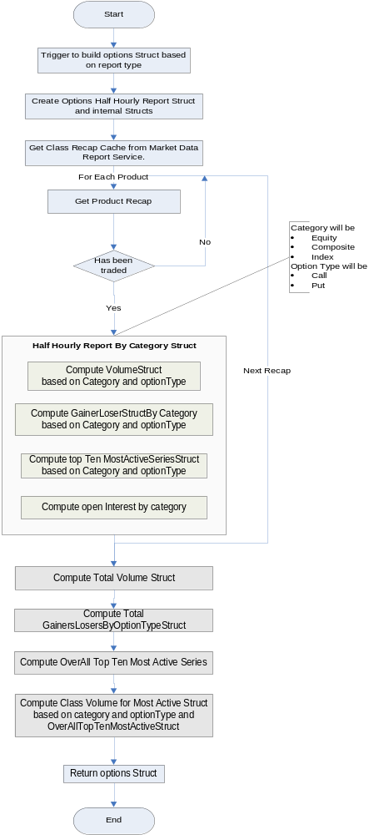

- Half Hourly Report By Category Struct:
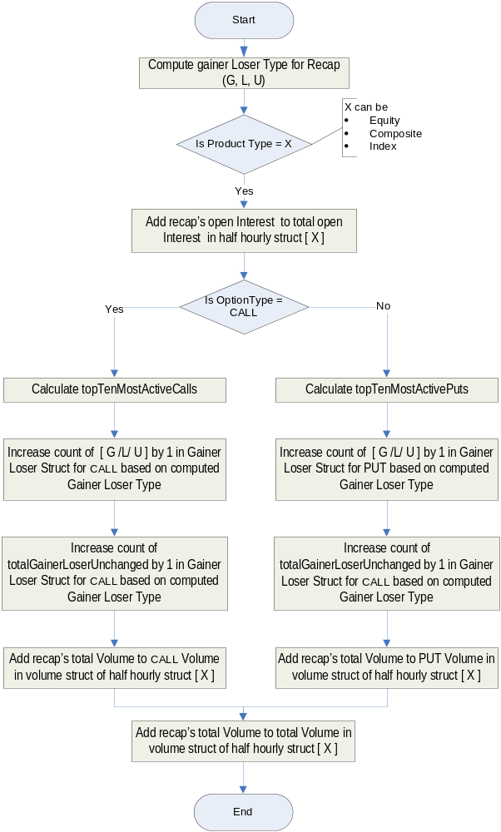

- Most Active Series Struct Sequence:
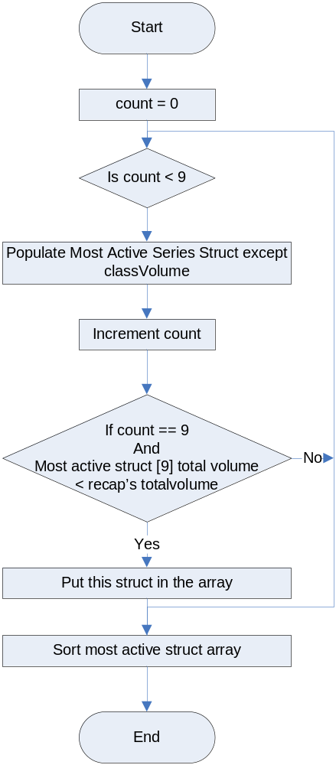

- Class Volume Calculation For Most Active Series:

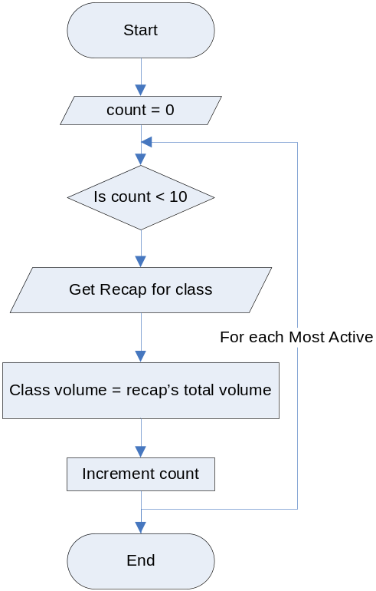

- ClassVolumeStructBuilder.java
Location: server/Java/impls/com/cboe/businessServices/marketDataReportService/
This class builds the ClassVolumeStruct.
  - Define method public static getClassVolumeStruct(String sessionName, int classKey)
    - Define variable ClassVolumeStruct classVolumeStruct
    - Get the Products Hashmap for entered class by calling MarketDataReportProcessorImpl. getRecaMapForClassKeyFromCache ( int classKey)
    - Checks if the Products are available for the given classKey or not.
    - If no products are found for the classKey Throws the NotFoundException.
    - Gets the lock on the obtained products hashmap by using synchronized block.
    - Builds the classVolumeStruct by iterating through the products Map.
    - Releases the lock on the product Map
    - Returns classVolumeStruct.

- Class Volume Struct Population Flow:

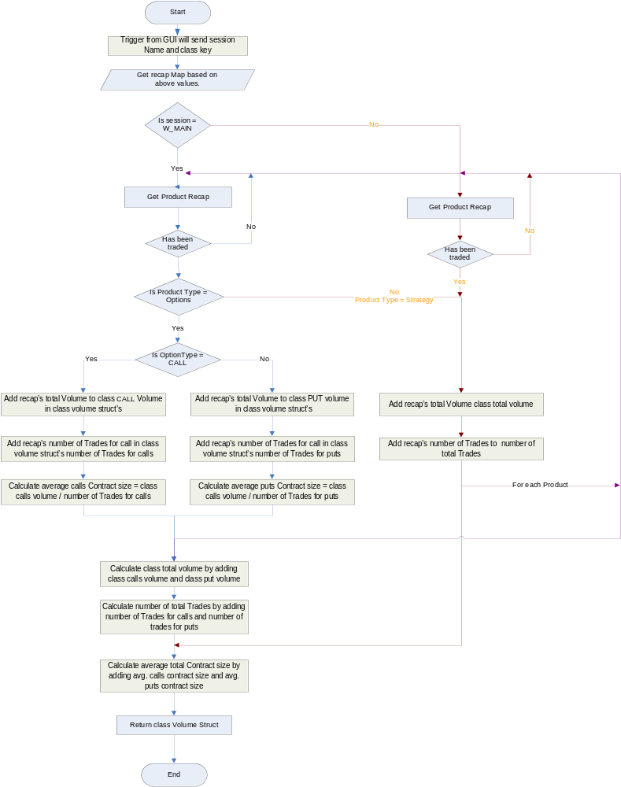

Database(.5)
A new schema for the MarketDataReportService will be created
Following tables will be created as a part of the new schema.
market_data_hist_for_reports

This table will be used creating reports containing history details

create table market_data_hist_for_reports
(
databaseIdentifier number(20) not null,
session_name varchar2(30) not null,
prod_key number(20) not null,
entry_type number(2) not null,
entry_time number(16) not null,
last_sale_price varchar2(12),
last_sale_vol number(10),
product_state number(2),
ticker_prefix varchar2(4),
dayofweek number(1) not null,
CREAT_REC_TIME timestamp default systimestamp
);
- recap_for_reports
Similar to table recap in domain/sql/ddl/Recap.sql
create table recap_for_reports
(
databaseIdentifier number(20) not null,
session_name varchar2(30) not null,
class_key number(20) not null,
product_key number(20) not null,
prod_type_code number(2) ,
opt_type_code varchar2(4) ,
number_Of_Trades number(20),
open_interest number(10),
underlying_price varchar2(12),
last_sale_price varchar2(12),
last_sale_vol number(10),
last_sale_price_vol number(10),
total_vol number(10),
trade_time number(16),
tick_dir char(1),
tick_amt varchar2(12),
net_chg varchar2(12),
net_chg_dir char(1),
bid_price varchar2(12),
bid_size number(10),
bid_time number(16),
bid_dir char(1),
ask_price varchar2(12),
ask_size number(10),
ask_time number(16),
otc_ind char(1),
recap_prefix varchar2(20),
high_price varchar2(12),
high_price_vol number(10),
low_price varchar2(12),
low_price_vol number(10),
open_price varchar2(12),
open_price_vol number(10),
close_price varchar2(12),
lowPriceTime number(20),
highPriceTime number(20),
openingPriceTime number(20),
underlying_category number(2),
has_been_traded_ind char(1)
);

XML/DTD(.5)

Define a xml in directory server/properties/xml.
- MarketDataReportService.xml
This XML will provide configurable properties for market data report consumer location in
marketDataReportConsumerImpl tag.
- MarketDataReportProcessor.xml
This XML will provide following configurable properties for each session.
  - sessionName –session name
  - numberBuildThreads - Number of threads to be used for building recap cache for this session
  - isClassModulus - If true ,distribution of last sale data on processing /history queues will be based on modulus of classkey else it will use modulus of product key.
  - productCacheSize –product cache will be initialized to this size
  - listOfProcessingQueues-Processing queue name list
Each processing queue name will provide following configurable properties- noOfQueues, dequeueBlockSize & blockWaitTime
  - listOfOpenInterestQueues
Each open Interest queue name will provide following configurable properties- noOfQueues, dequeueBlockSize & blockWaitTime

- MDRSPropertyHome.xml
This XML will provide following configurable properties for MarketDataReportService - listOfSessions, listOfGroupNames, instanceId, instanceNbr. These properties will be used for exporting MarketDataReportService in Master/Master mode

Define a dtd in directory server/properties/dtd for each of the xml above.
- MarketDataReportService.dtd
- MarketDataReportProcessor.dtd
- MDRSPropertyHome.dtd

ImplPlan(.5)

PerformanceTestingProcedure(1)
- List all scenarios here.

TestingProcedure(1)
- List all scenarios here.

OperatorProcedure(.5)
- Describe how to start/end session, EOD/purge on desired trade servers.

Fallback/Failover
- List how fallback/failover will be achieved after rollout.
Appendix-A
- MarketDataReportService.xml

- MarketDataReportProcessor.xml

- MDRSPropertyHome.xml
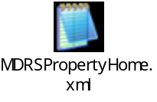
- List of Files

